WEEK – 2

Nipuna Amanapu

Superset id: 6432842

**Exercise 3: Stored Procedures**

**Scenario 1:** The bank needs to process monthly interest for all savings accounts.

* + **Question:** Write a stored procedure **ProcessMonthlyInterest** that calculates and updates the balance of all savings accounts by applying an interest rate of 1% to the current balance.

Solution:

1)bank_setup.sql :

CREATE TABLE savings_accounts (

    account_id NUMBER PRIMARY KEY,

    customer_name VARCHAR2(100),

    balance NUMBER

);

INSERT INTO savings_accounts VALUES (1, 'Alice', 10000);

INSERT INTO savings_accounts VALUES (2, 'Bob', 15000);

INSERT INTO savings_accounts VALUES (3, 'Charlie', 20000);

COMMIT;

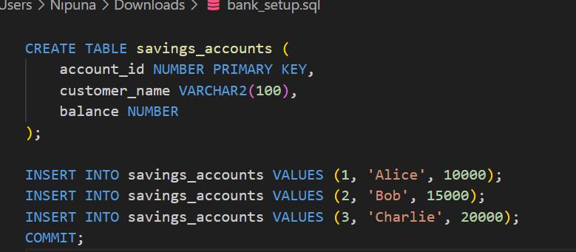

2)process_interest.sql :

CREATE OR REPLACE PROCEDURE ProcessMonthlyInterest IS

BEGIN

    UPDATE savings_accounts

    SET balance = balance + (balance * 0.01);

    COMMIT;

END;

/

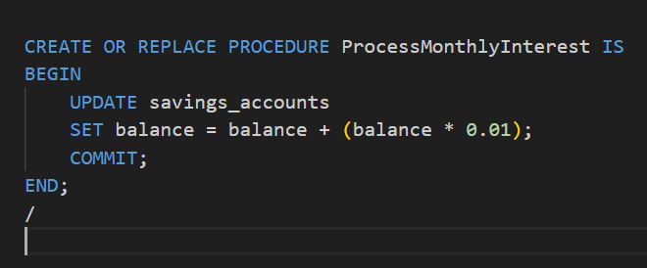

3)run_interest.sql :

BEGIN

    ProcessMonthlyInterest;

END;

/

SELECT * FROM savings_accounts;

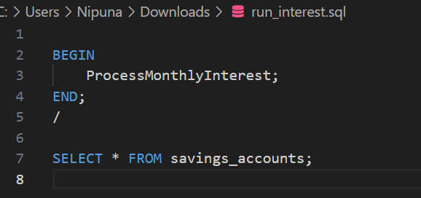

Output :

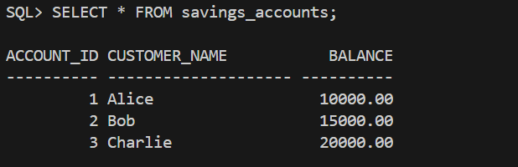

**Scenario 2:** The bank wants to implement a bonus scheme for employees based on their performance.

* + **Question:** Write a stored procedure **UpdateEmployeeBonus** that updates the salary of employees in a given department by adding a bonus percentage passed as a parameter.

Solution :

1)employee_setup.sql :

CREATE TABLE employees (

    employee_id NUMBER PRIMARY KEY,

    name VARCHAR2(100),

    department VARCHAR2(50),

    salary NUMBER

);

INSERT INTO employees VALUES (1, 'Alice', 'HR', 50000);

INSERT INTO employees VALUES (2, 'Bob', 'Finance', 60000);

INSERT INTO employees VALUES (3, 'Charlie', 'HR', 55000);

INSERT INTO employees VALUES (4, 'David', 'IT', 70000);

INSERT INTO employees VALUES (5, 'Eve', 'Finance', 65000);

COMMIT;

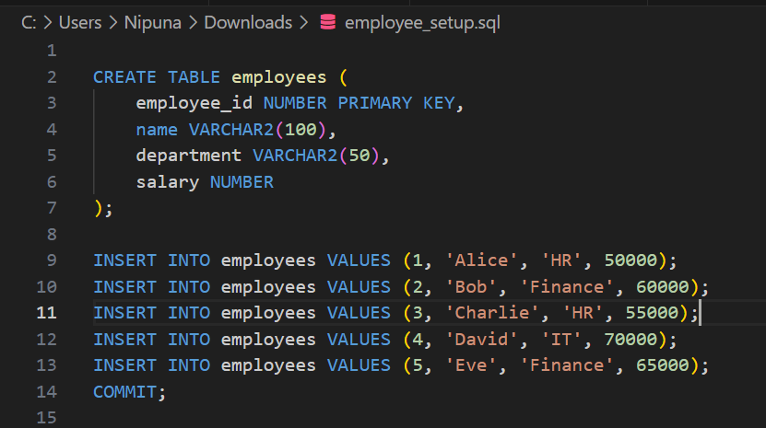

2)update_bonus_proc :

CREATE OR REPLACE PROCEDURE UpdateEmployeeBonus (

    dept_name IN VARCHAR2,

    bonus_percent IN NUMBER

) IS

BEGIN

    UPDATE employees

    SET salary = salary + (salary * bonus_percent / 100)

    WHERE department = dept_name;

    COMMIT;

END;

/

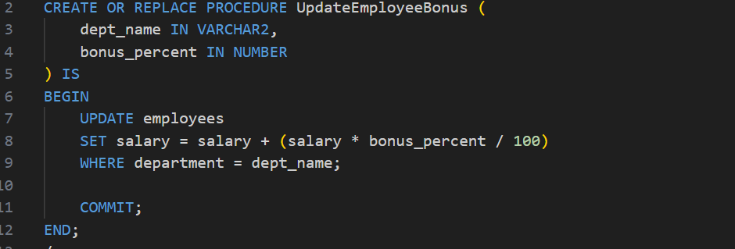

3)run_bonus_update :

SET LINESIZE 100

SET PAGESIZE 50

COLUMN employee_id FORMAT 999

COLUMN name FORMAT A15

COLUMN department FORMAT A12

COLUMN salary FORMAT 999999.99

BEGIN

    UpdateEmployeeBonus('HR', 10);

END;

/

SELECT * FROM employees;

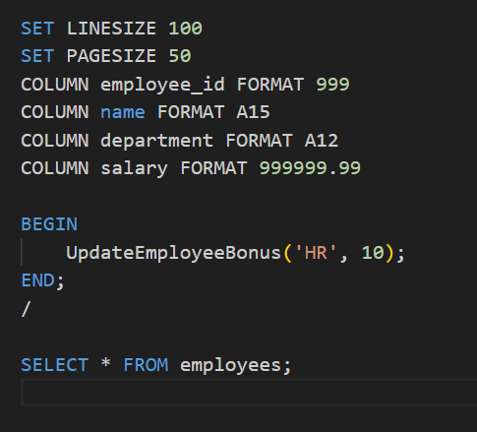

Output :

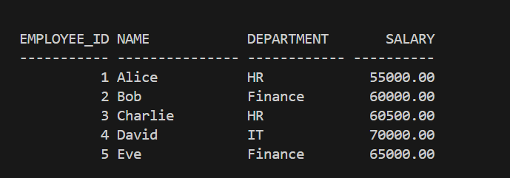

**Scenario 3:** Customers should be able to transfer funds between their accounts.

* + **Question:** Write a stored procedure **TransferFunds** that transfers a specified amount from one account to another, checking that the source account has sufficient balance before making the transfer.

Solution :

1)account_setup.sql :

CREATE TABLE bank_accounts (

    account_id NUMBER PRIMARY KEY,

    customer_name VARCHAR2(100),

    balance NUMBER

);

INSERT INTO bank_accounts VALUES (101, 'Alice', 10000);

INSERT INTO bank_accounts VALUES (102, 'Bob', 8000);

INSERT INTO bank_accounts VALUES (103, 'Charlie', 12000);

COMMIT;

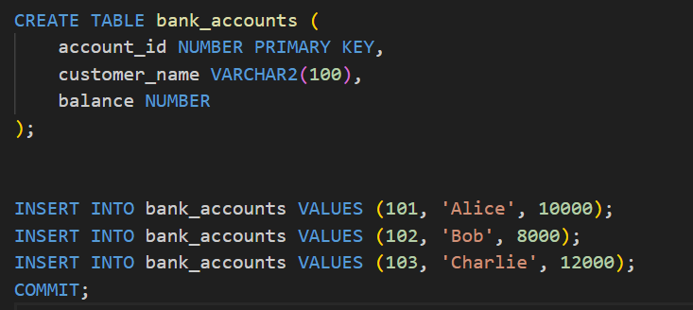

2)transfer_funds_proc.sql :

CREATE OR REPLACE PROCEDURE TransferFunds (

    from_account_id IN NUMBER,

    to_account_id IN NUMBER,

    amount IN NUMBER

) IS

    from_balance NUMBER;

BEGIN

    SELECT balance INTO from_balance

    FROM bank_accounts

    WHERE account_id = from_account_id;

    IF from_balance < amount THEN

        RAISE_APPLICATION_ERROR(-20001, 'Insufficient balance in source account.');

    END IF;

    UPDATE bank_accounts

    SET balance = balance - amount

    WHERE account_id = from_account_id;

    UPDATE bank_accounts

    SET balance = balance + amount

    WHERE account_id = to_account_id;

    COMMIT;

END;

/

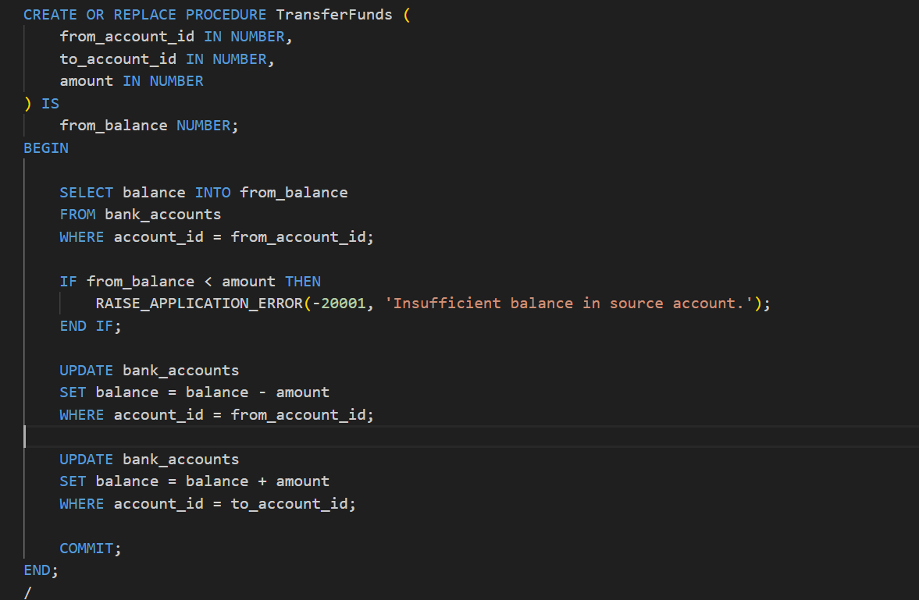

3)run_transfer.sql :

SET LINESIZE 100

SET PAGESIZE 50

COLUMN account_id FORMAT 999

COLUMN customer_name FORMAT A15

COLUMN balance FORMAT 999999.99

BEGIN

    TransferFunds(101, 102, 3000);

END;

/

SELECT * FROM bank_accounts;

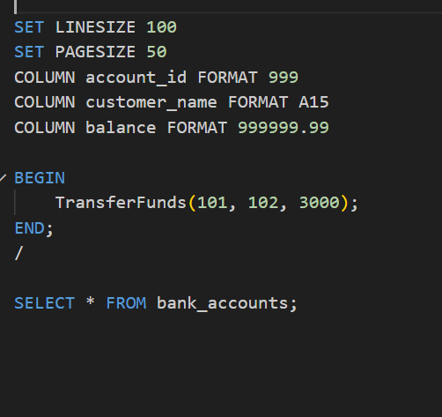

Output :

